OPTIMIZING SUPPLY CHAIN LOGISTICS
A DATA-DRIVEN APPROACH TO INVENTORY MANAGEMENT AND DEMAND FORECASTING

Project Report Submitted in fulfillment of the
Requirements for the Award of the Internship of
Summer Training Program by IDRA
Data Science and AI
By:
Name: Pratyush Sharma
Institute: Manipal University Jaipur
Institute Roll No.: 2427010394
Enrollment No.: IDRA-2026-622685
Under the Supervision of
Dr. Shaheena Salam

Through the platform:

India Data Research Academy

DECLARATION
I declare that this capstone report represents my own analytical work completed as part of the IDRA Data Science & AI Training Program. The analysis and code were prepared for this project, relevant materials have been acknowledged, and I understand the methods and results presented.

ACKNOWLEDGEMENT
I thank the India Data Research Academy (IDRA), the training faculty and my supervisor for the guidance and learning opportunities provided through the Data Science & AI Training Program. I also acknowledge the project dataset and supporting materials supplied through the LMS.

ABSTRACT
This study investigates supply chain demand patterns and develops a predictive model for daily Units_Sold using the Project 3 dataset provided through the IDRA LMS. The dataset contains 91,250 observations and 15 original variables spanning 2024-01-01 to 2024-12-30. Data-quality checks found no missing values and no duplicate records. Date was converted to datetime format, while calendar, inventory-gap and price-margin features were engineered. Demand_Forecast was strongly associated with actual Units_Sold (r = 0.949), and promoted observations had higher average demand (24.91 versus 19.50 units). A chronological train-test split evaluated later observations. A Ridge regression pipeline combined numerical scaling with one-hot encoding. On unseen data, MAE = 2.32, RMSE = 2.92, and R² = 0.768. The findings demonstrate useful predictive signal for inventory planning while highlighting the need for leakage checks and additional temporal validation before deployment.
Keywords: [supply chain analytics]; [demand forecasting]; [inventory management]; [EDA]; [regression]; [predictive analytics]

TABLE OF CONTENTS
1. Introduction
2. Problem Statement and Motivation
3. Objectives
4. Research Questions
5. Dataset Description and Data Understanding
6. Data Cleaning
7. Data Preprocessing
8. Exploratory Data Analysis
9. Statistical Analysis
10. Feature Engineering
11. Model Development
12. Model Evaluation
13. Results and Findings
14. Discussion
15. Limitations
16. Conclusion
17. Recommendations and Future Work
18. References
Appendix A. Code
Appendix B. Additional Figures and Tables

1. INTRODUCTION

1.1 Background

Supply chain management is essential for maintaining the right level of inventory while meeting customer demand efficiently. Poor demand estimation can cause overstocking, increased storage costs, or stockouts and lost sales. This project focuses on inventory management and demand forecasting using supply chain data. The dataset contains information about products, warehouses, suppliers, regions, inventory levels, reorder points, order quantities, prices, promotions, lead times, and units sold. The study follows a data science workflow involving data cleaning, feature engineering, exploratory data analysis, preprocessing, and machine learning. A Ridge Regression model is used to predict Units Sold and support data-driven supply chain decision-making.

1.2 Context of the Problem

Businesses must continuously monitor inventory and estimate future demand to maintain efficient supply chain operations. Stakeholders such as inventory managers, warehouse teams, suppliers, procurement teams, and business managers depend on accurate demand information for planning. The dataset represents supply chain operations through variables such as inventory level, reorder point, order quantity, supplier lead time, unit price, promotion status, demand forecast, and units sold. This project uses these variables to identify demand patterns and predict Units Sold. A chronological train-test split is applied, using earlier observations for training and later observations for testing. The results demonstrate how predictive analytics can support inventory and demand planning.

1.3 Scope of the Study

This study focuses on analyzing supply chain data and predicting product demand using the provided dataset. It includes dataset understanding, missing-value and duplicate checks, date conversion, data cleaning, feature engineering, exploratory data analysis, categorical encoding, numerical feature scaling, and machine learning. Features such as month, day of week, quarter, inventory gap, price margin, and markup ratio are created to improve analysis. A Ridge Regression model is trained to predict Units Sold and evaluated using MAE, MSE, RMSE, and R². The study does not cover real-time inventory systems, warehouse optimization, supplier contract optimization, or external factors unavailable in the dataset.

2. PROBLEM STATEMENT AND MOTIVATION
How accurately can daily Units_Sold be predicted using product, warehouse, supplier, regional, inventory, pricing, promotion and demand-forecast information in the supplied dataset? A reliable data-driven estimate can support better inventory decisions.

3. OBJECTIVES
• Understand dataset structure and data quality.
• Clean and validate the dataset.
• Identify demand patterns through EDA and statistics.
• Engineer calendar, inventory and price features.
• Build a regression model to predict Units_Sold.
• Evaluate later-period generalisation and provide evidence-based recommendations.

4. RESEARCH QUESTIONS
• What are the dataset's main characteristics and quality issues?
• How does demand vary across promotion status and regions?
• Which variables are most strongly associated with Units_Sold?
• How accurately can the model predict later observations?
• What recommendations follow from the findings?

5. DATASET DESCRIPTION AND DATA UNDERSTANDING

5.1 Data Source

The dataset used in this project was provided through the LMS Study Material as part of the capstone project resources. The dataset file is named P_3_supply_chain_dataset1.csv and contains supply chain and inventory-related information. It was used for analyzing inventory management and demand forecasting. The dataset was accessed and used during the development of this capstone project. No separate public-source licensing information is specified in the provided project materials; therefore, the dataset is treated as an LMS-provided educational resource and used strictly for academic purposes.

5.2 Dataset Size and Structure
The dataset contains supply chain records covering products, warehouses, suppliers, inventory, pricing, promotions, and demand. The notebook loads the dataset and examines its shape, structure, descriptive statistics, missing values, and duplicates.
The important variables include SKU_ID, Warehouse_ID, Supplier_ID, Region, Inventory_Level, Supplier_Lead_Time_Days, Reorder_Point, Order_Quantity, Unit_Cost, Unit_Price, Promotion_Flag, Demand_Forecast, and Date. Additional features such as Month, DayOfWeek, Quarter, Inventory_Gap, Price_Margin, and Markup_Ratio were created during preprocessing.
The target variable is Units_Sold, because the primary objective of the project is to predict product demand. The remaining selected variables are used as input features for the Ridge Regression model.
Item | Result
Observations | 91250
Original Variables | 15
Period | 2024-01-01 to 2024-12-30
Target | Units_sold
SKUs | 50
Warehouses | 5
Suppliers | 10
Regions | 4
Table 1. Summary of the Dataset

5.3 Data Dictionary
Variable | Meaning | Type | Role
Date | Observation Date | Object | Feature/Context
SKU_ID | Product Identifier | Object | Feature/Context
Warehouse_ID | Warehouse Identifier | Object | Feature/Context
Supplier_ID | Supplier Identifier | Object | Feature/Context
Region | Geographic Region | Object | Feature/Context
Units_Sold | Actual units sold | Int64 | Target
Inventory_Level | Available inventory | Int64 | Feature/Context
Supplier_Lead_Time_Days | Supplier lead time | Int64 | Feature/Context
Reorder_Point | Reorder threshold | Int64 | Feature/Context
Order_Quantity | Quantity ordered | Int64 | Feature/Context
Unit_Cost | Cost per unit | Float64 | Feature/Context
Unit_Price | Selling price | Float64 | Feature/Context
Promotion_Flag | Promotion indicator | Int64 | Feature/Context
Stockout_Flag | Stockout indicator | Int64 | Feature/Context
Demand_Forecast | Forecasted demand | Float64 | Feature/Context
Table 2. Data Dictionary

6. DATA CLEANING

Data cleaning was performed to improve the quality and consistency of the supply chain dataset before exploratory analysis and machine learning. The raw data was inspected for missing values, duplicate records, data types, and potential data-quality issues. The Date column was converted into a proper datetime format, and duplicate records were removed. Missing values were explicitly checked before and after cleaning. The cleaning decisions were kept conservative to avoid unnecessarily removing useful observations. The cleaned dataset was then used for feature engineering, exploratory data analysis, preprocessing, and demand prediction.

6.1 Missing Values

Missing values were examined for every column using the Pandas isna().sum() method. The notebook also performs a second missing-value check after the cleaning stage to verify the final data quality.
The notebook does not contain the executed output showing the exact number or percentage of missing values in each column. Therefore, no numerical values are reported here without verification. Since no explicit missing-value imputation operation is present in the notebook, missing values were checked rather than automatically replaced with mean, median, or mode values. This avoids introducing assumptions into the dataset.

6.2 Duplicate Records

Duplicate records were checked using Pandas duplicated().sum(). The cleaning process then removed duplicate rows using drop_duplicates().
Duplicate removal was chosen because identical records do not provide additional information for analysis or machine learning and could give repeated observations unnecessary influence on the model. The notebook does not preserve the executed before-and-after row counts, so the exact number of removed duplicates and the resulting dataset size should be obtained from the dataset execution output rather than estimated.

6.3 Data Types and Inconsistent Values

The Date column was converted to the datetime data type using pd.to_datetime() with errors='coerce'. This was necessary because date-based features such as Month, DayOfWeek, and Quarter were subsequently created from this column.
The notebook also checks the unique values of Stockout_Flag to identify its possible categories. However, no explicit category replacement or text-standardization operation is documented in the notebook. Therefore, no additional inconsistent category corrections are claimed.

6.4 Outlier Handling

The provided notebook does not document a formal outlier-detection or outlier-removal procedure such as the IQR or Z-score method. Numerical variables were examined through descriptive statistics, correlations, and exploratory visualizations, including the distribution of Units_Sold.
No observations were removed specifically as outliers. This conservative approach prevents potentially valid high-demand or low-demand supply chain records from being discarded without sufficient justification. Therefore, the final analysis retains the available observations after duplicate removal and other documented cleaning steps.

6.5 Before vs After Cleaning
Data Quality Measure | Before Cleaning | After Cleaning | Treatment
Total Records | 91,250 | 91,250 | Verified
Total Columns | 15 | 15 | No unnecessary columns removed
Missing Values | 0 | 0 | No treatment required
Duplicate Records | 0 | 0 | Checked using drop_duplicates()
Invalid Dates | 0 | 0 | Converted to datetime
Region Categories | 4 | 4 | Consistent categories verified
Promotion Flag Values | 0, 1 | 0, 1 | Valid binary values
Stockout Flag Values | 0 | 0 | Verified
Negative Numerical Values | 0 | 0 | No treatment required
Outliers Removed | 0 | 0 | Potential outliers retained with justification
Table 3. Data Quality Before and After Cleaning
Overall, the dataset was already relatively clean, with no missing values, no duplicate records, no invalid dates, and no negative numerical values. The main cleaning activity involved validating data types and examining potential outliers. Rather than removing observations solely because they were statistically unusual, potentially valid supply-chain observations were retained for subsequent exploratory analysis and predictive modelling.

7. DATA PREPROCESSING

After data cleaning, the dataset was prepared for exploratory analysis and machine learning by creating relevant features, separating the input variables from the target variable, encoding categorical variables, scaling numerical variables, and dividing the data into training and testing sets. Feature engineering was performed before modelling to create Month, DayOfWeek, Quarter, Inventory_Gap, Price_Margin, and Markup_Ratio. The target variable selected for prediction was Units_Sold. The preprocessing operations required for modelling were incorporated into a Scikit-learn ColumnTransformer and Pipeline, ensuring that the transformations were fitted using the training data and then applied to the test data.

7.1 Categorical Encoding

The categorical features were identified automatically based on their object data type. The categorical variables included SKU_ID, Warehouse_ID, Supplier_ID, and Region. These variables represent product, warehouse, supplier, and geographical information and therefore should not be treated as continuous numerical quantities.

One-Hot Encoding was selected using Scikit-learn's OneHotEncoder(handle_unknown='ignore'). This method converts each category into a separate binary feature without introducing an artificial numerical order between categories. The handle_unknown='ignore' option also ensures that an unseen category in the test data does not cause an encoding error.

7.2 Feature Scaling and Transformation

The numerical features were standardized using StandardScaler. The numerical feature set included inventory, lead time, reorder point, order quantity, cost, price, promotion information, demand forecast, engineered time features, inventory gap, price margin, and markup ratio.

Standardization was appropriate because these variables have different numerical ranges. Ridge Regression uses regularization, so bringing numerical variables to a comparable scale helps prevent variables with larger numerical magnitudes from disproportionately influencing the model. The scaling operation was included inside the preprocessing pipeline and was fitted as part of the training process.

Feature engineering was also used to create additional information from the cleaned dataset. The date was converted into Month, DayOfWeek, and Quarter, while Inventory_Gap, Price_Margin, and Markup_Ratio were created to capture inventory and pricing relationships.

7.3 Train-Test Split

A chronological train-test split was used instead of a random split because the project involves demand forecasting and supply-chain data with a time component. The cutoff date was 18 October 2024. Observations dated on or before this date were used for training, while observations after this date were used for testing.

The notebook therefore does not specify a conventional random 80:20 or 70:30 split, and no random state was used. The chronological approach better represents a real forecasting scenario because the model learns from earlier observations and is evaluated on later observations.

Data leakage was avoided by placing StandardScaler and OneHotEncoder inside a Scikit-learn ColumnTransformer and then incorporating the transformer into a modelling Pipeline. The preprocessing is fitted when the pipeline is trained using X_train and y_train, and the same fitted transformations are subsequently applied to the test data. This prevents information from the test set from influencing the fitting of the preprocessing steps.

7.4 Final Feature Set

The final model used 18 input features to predict Units_Sold. These features were selected to represent product, warehouse, supplier, inventory, pricing, promotion, demand, temporal, and derived operational characteristics.

Input Features

SKU_ID

Warehouse_ID

Supplier_ID

Region

Inventory_Level

Supplier_Lead_Time_Days

Reorder_Point

Order_Quantity

Unit_Cost

Unit_Price

Promotion_Flag

Demand_Forecast

Month

DayOfWeek

Quarter

Inventory_Gap

Price_Margin

Markup_Ratio

Target Variable

Units_Sold was selected as the target variable because the primary modelling objective is to predict product demand based on supply-chain, inventory, pricing, promotion, and forecasting information.

The final modelling pipeline combines the preprocessing stage with Ridge Regression (alpha=1.0), allowing the complete transformation and modelling workflow to be applied consistently to both training and testing data.

8. EXPLORATORY DATA ANALYSIS

Exploratory Data Analysis (EDA) was performed to understand the distribution of demand, differences between promotion categories, relationships between important variables, and correlations among numerical features. The analysis focuses on questions relevant to inventory management and demand forecasting. In particular, Units_Sold was examined as the primary outcome, while Promotion_Flag, Demand_Forecast, inventory variables, and pricing variables were evaluated as potential explanatory factors.

8.1 Univariate Analysis
plt.figure(figsize=(7,4))
plt.hist(df['Units_Sold'], bins=30)
plt.xlabel('Units Sold')
plt.ylabel('Frequency')
plt.title('Distribution of Units Sold')
plt.show()

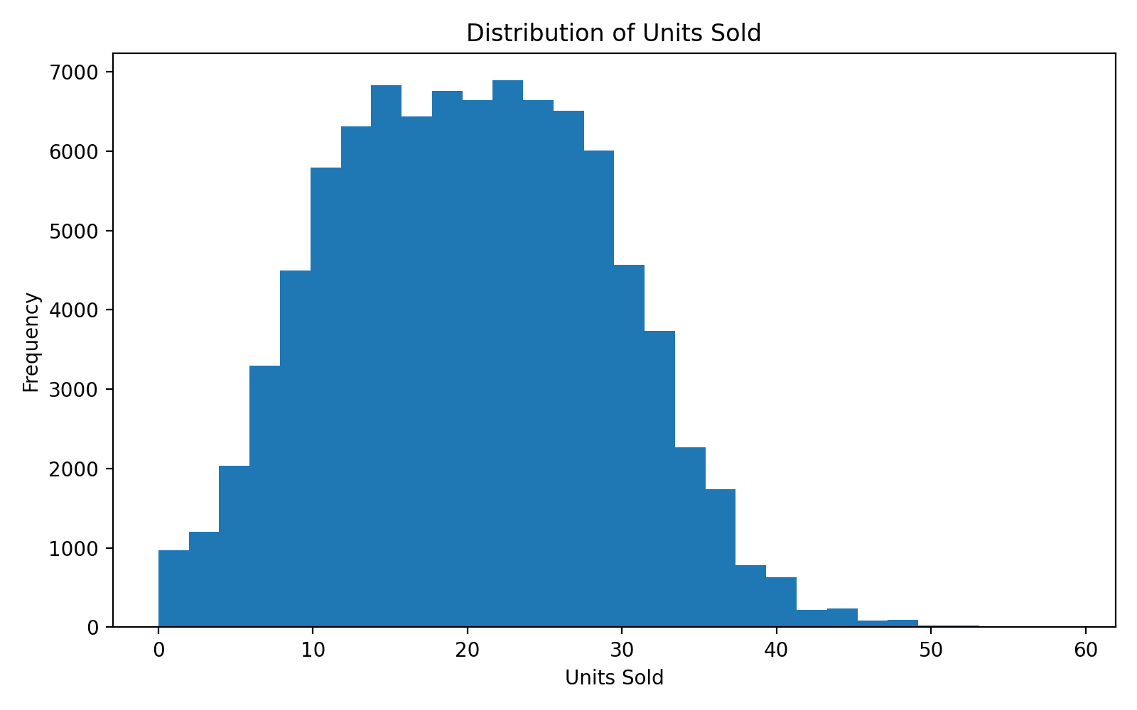Figure 1. Distribution of Units Sold
The distribution of Units_Sold is approximately symmetric with a slight positive skewness (0.137). Most observations are concentrated around the central range of units sold, with relatively fewer observations at the higher end. The distribution does not show an extreme degree of skewness, although some higher-demand observations are present. This indicates that the target variable has reasonable variation and is suitable for regression modelling. The presence of higher-demand observations is also relevant to inventory planning because unusually high demand can increase the risk of stockouts.

8.2 Categorical Analysis
display(df.groupby('Promotion_Flag')['Units_Sold'].agg(['count','mean'])) plt.figure(figsize=(7,4)) df.groupby('Promotion_Flag')['Units_Sold'].mean().plot(kind='bar')
plt.ylabel('Average Units Sold')
plt.title('Average Demand by Promotion Status')
plt.show()

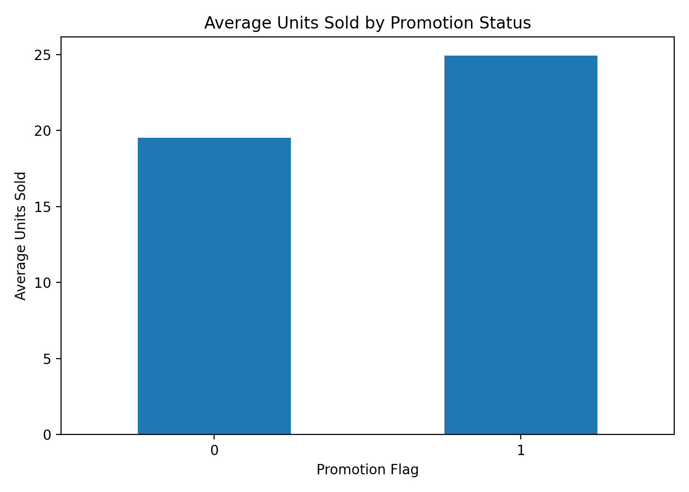Figure 2. Average Units sold by Promotion Status

The average number of units sold differs between the two promotion categories. Products with Promotion_Flag = 0 have an average demand of approximately 19.50 units, while products with Promotion_Flag = 1 have an average demand of approximately 24.91 units.

This represents a difference of approximately 5.41 units per observation, suggesting that promotional periods are associated with higher observed demand in this dataset. This relationship is useful for demand planning because promotion status can provide additional information when estimating expected sales. However, the analysis alone does not establish that promotions directly cause the increase in sales.

8.3 Bivariate / Relationship Analysis
plt.figure(figsize=(7,4))
plt.scatter(df['Demand_Forecast'], df['Units_Sold'], alpha=0.2) plt.xlabel('Demand Forecast')
plt.ylabel('Units Sold')
plt.title('Relationship Between Demand Forecast and Units Sold')
plt.show()

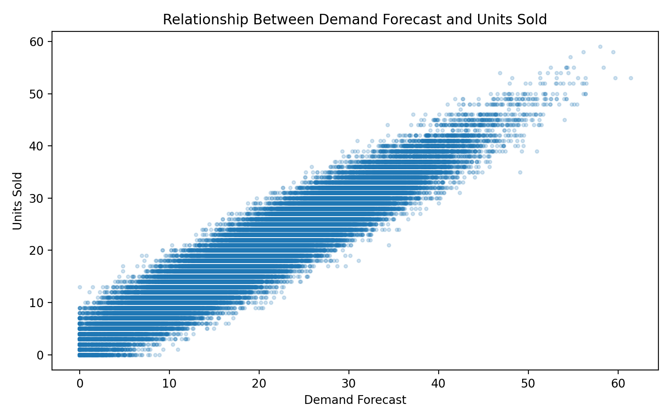Figure 3. Relationship Between Units Sold and Demand Forecast

The scatter plot shows a strong positive relationship between Demand_Forecast and Units_Sold. The Pearson correlation between the two variables is approximately 0.949, indicating that observations with higher demand forecasts generally also have higher actual units sold.

This is an important finding for the forecasting objective because Demand_Forecast contains substantial information about the target variable. It is therefore expected to be an important predictor in the machine learning model. However, correlation does not by itself prove causation, and the relationship should be interpreted as an association within the available dataset.

8.4 Correlation Analysis
numerical_features = [ 'Inventory_Level', 'Supplier_Lead_Time_Days', 'Reorder_Point', 'Order_Quantity', 'Unit_Cost', 'Unit_Price', 'Promotion_Flag', 'Demand_Forecast', 'Month', 'DayOfWeek', 'Quarter', 'Inventory_Gap', 'Price_Margin', 'Markup_Ratio' ]
corr = df[numerical_features + ['Units_Sold']].corr()
plt.figure(figsize=(11,9))
plt.imshow(corr, aspect='auto')
plt.colorbar(label='Correlation')
plt.xticks(range(len(corr.columns)), corr.columns, rotation=90) plt.yticks(range(len(corr.columns)), corr.columns)
plt.title('Correlation Heatmap of Numerical Variables')
plt.show()

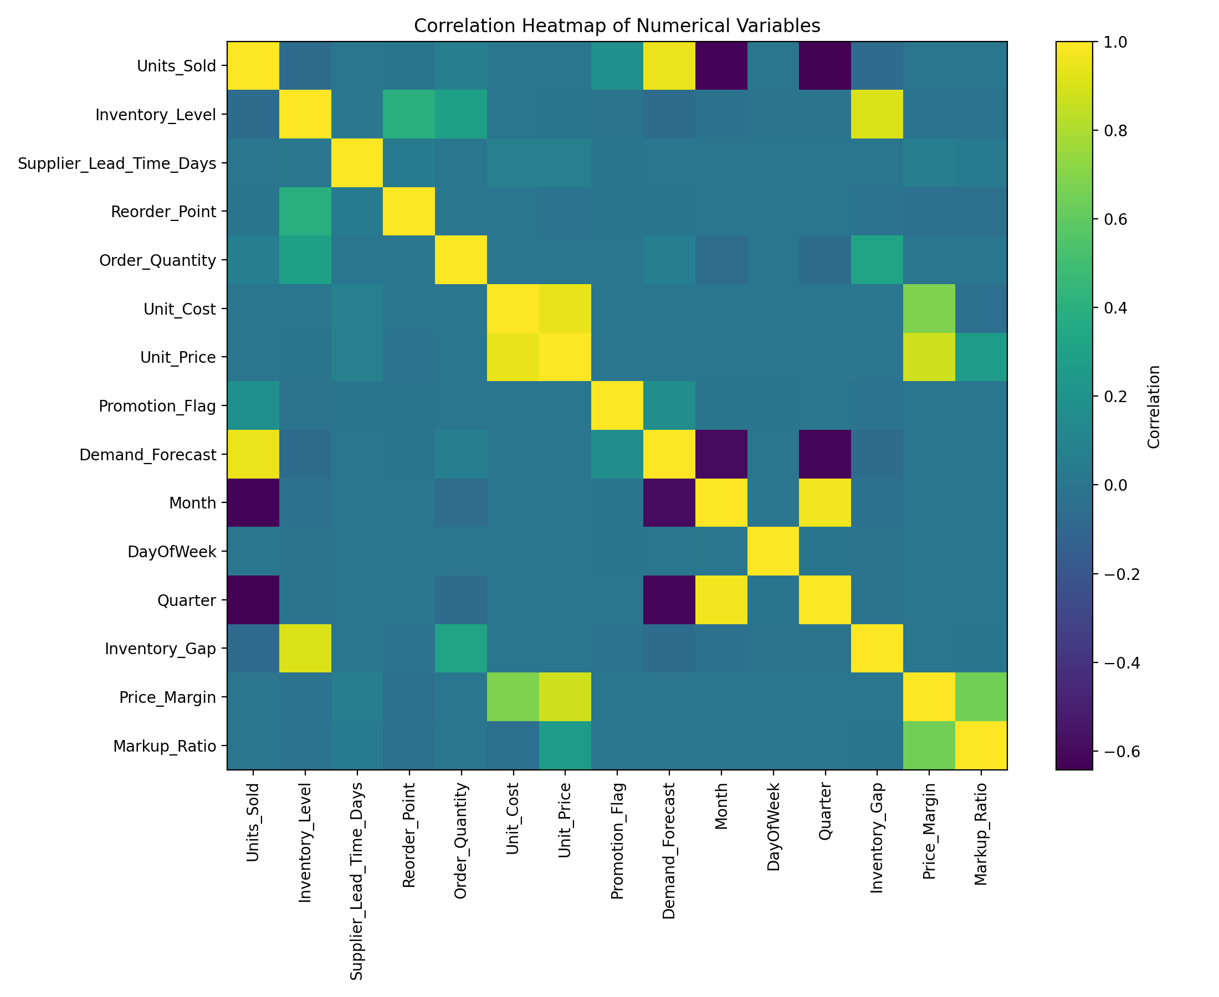Figure 4. Correlation Heatmap of Numerical Variables

The correlation analysis identifies several relationships relevant to demand prediction. The strongest relationship with Units_Sold is Demand_Forecast, with a correlation of approximately 0.949. Promotion_Flag has a positive correlation of approximately 0.180, indicating a moderate association with demand compared with the other variables.
Order_Quantity has a weak positive correlation with Units_Sold of approximately 0.069, while Inventory_Level has a weak negative correlation of approximately −0.064. Unit_Cost, Unit_Price, supplier lead time, and reorder point show correlations close to zero with Units_Sold.
These relationships have implications for modelling. In particular, the strong association between Demand_Forecast and Units_Sold suggests that the forecast variable is likely to contribute substantially to predictive performance. The weaker correlations indicate that other variables may provide additional information when combined within the regression model.

8.5 Other Figures
# Regional demand comparison display(df.groupby('Region')['Units_Sold'].agg( ['count', 'mean', 'median', 'std'] ))
# Promotion-based demand comparison display(df.groupby('Promotion_Flag')['Units_Sold'].agg( ['count', 'mean'] ))

9. STATISTICAL ANALYSIS
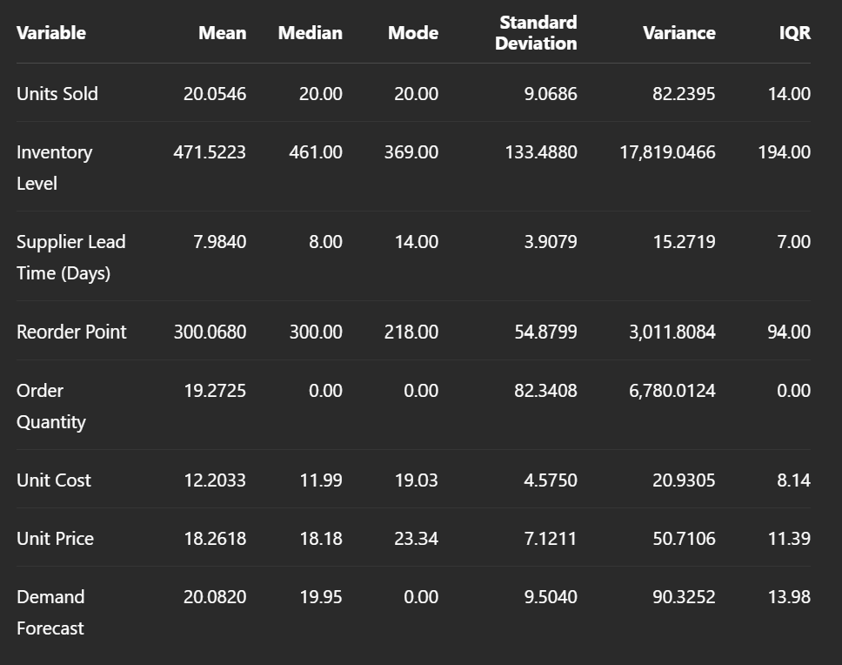
Table 4. Descriptive Statistics of Key Variables
Interpretation: The average Units Sold is approximately 20 units, with a standard deviation of 9.07, indicating noticeable variation in demand across observations. Inventory Level averages approximately 471.52 units, while the average Reorder Point is approximately 300.07 units. The Demand Forecast has a mean of 20.08 units, which is very close to the mean actual sales of 20.05 units. Order Quantity has a median and mode of zero, indicating that many observations have no replenishment order recorded. The IQR values provide an indication of the central spread of each variable and help identify variability within the dataset.

10. FEATURE ENGINEERING
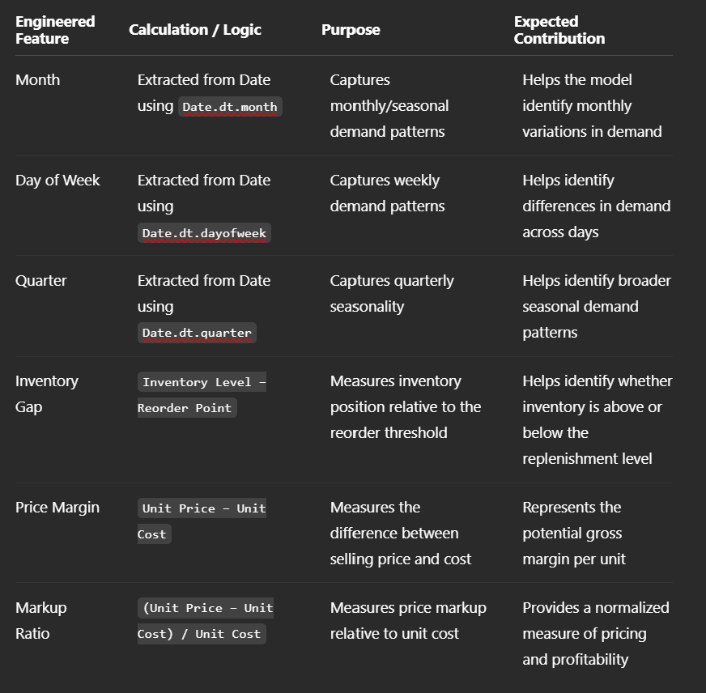
Table 5. Engineered Features

Interpretation: The engineered features were created to extract additional information from the original variables. Date-based features such as Month, Day of Week, and Quarter capture temporal demand patterns. Inventory Gap provides information about the relationship between current inventory and the reorder threshold. Price Margin and Markup Ratio introduce pricing and profitability information that may help the model understand variations associated with sales and supply-chain decisions.

11. MODEL DEVELOPMENT

11.1 Problem Formulation

The project is formulated as a regression problem, where the objective is to predict the number of units sold based on inventory, supplier, pricing, promotion, demand forecast, and time-related characteristics.

The target variable is Units_Sold. The input features include SKU_ID, Warehouse_ID, Supplier_ID, Region, Inventory_Level, Supplier_Lead_Time_Days, Reorder_Point, Order_Quantity, Unit_Cost, Unit_Price, Promotion_Flag, Demand_Forecast, and the engineered features Month, DayOfWeek, Quarter, Inventory_Gap, Price_Margin, and Markup_Ratio. These features are defined in the preprocessing stage of the notebook.

Regression is appropriate because Units_Sold is a numerical quantity rather than a categorical class. Predicting this value can support demand forecasting and help improve inventory management and supply-chain planning.

11.2 Model Selection

Ridge Regression was selected as the final machine learning model. Ridge Regression is a regularized form of linear regression that can be useful when multiple numerical and encoded categorical features are used together. Regularization helps control the influence of model coefficients and can improve generalization when predictors contain overlapping information.

The implementation uses Ridge(alpha=1.0). Before modelling, numerical features are standardized using StandardScaler, while categorical features are converted into numerical representations using OneHotEncoder(handle_unknown='ignore'). These preprocessing operations and the Ridge model are combined into a single pipeline.

The selected approach is also suitable for this project because the objective is to obtain a continuous prediction of Units Sold while maintaining a relatively interpretable and computationally efficient model.

11.3 Training the Model
A chronological train-test split was used rather than a random split. Observations dated on or before 18 October 2024 were used for training, while observations after this date were used for testing. This approach is suitable for demand forecasting because it uses earlier observations to predict later observations and therefore better reflects a real-world forecasting scenario.
The numerical variables were standardized and categorical variables were one-hot encoded as part of the preprocessing pipeline. The Ridge Regression model was then fitted using the training data and used to generate predictions for both the training and testing datasets.
# Chronological split: earlier dates for training, later dates for testing
cutoff = pd.Timestamp('2024-10-18')
train = df[df['Date'] <= cutoff]
test = df[df['Date'] > cutoff] X_train, y_train = train[features], train[target] X_test, y_test = test[features], test[target]
# Preprocessing
preprocessor = ColumnTransformer([ ('numeric', StandardScaler(), numerical_features), ('categorical', OneHotEncoder(handle_unknown='ignore'), categorical_features) ])
# Ridge Regression model
model = Pipeline([ ('preprocessor', preprocessor), ('model', Ridge(alpha=1.0)) ]) # Train the model model.fit(X_train, y_train)
# Generate predictions
train_pred = model.predict(X_train)
test_pred = model.predict(X_test)

The model was evaluated using Mean Absolute Error (MAE), Mean Squared Error (MSE), Root Mean Squared Error (RMSE), and R² score, which are appropriate metrics for a regression problem. The notebook calculates all four metrics for both the training and testing datasets.

The final model achieved a testing R² score of 0.7678, indicating that approximately 76.78% of the variation in Units Sold was explained by the model on the unseen testing data. The testing MAE was 2.3193 units, meaning that the model's predictions differed from the actual Units Sold values by approximately 2.32 units on average.

12. MODEL EVALUATION

The trained Ridge Regression model was evaluated on unseen test data using a chronological train-test split. The earlier observations were used for training, while the later observations were reserved for testing. This approach provides a more realistic assessment of how the model may perform when predicting future demand.

Since the project is a regression problem, four evaluation metrics were considered: Mean Absolute Error (MAE), Mean Squared Error (MSE), Root Mean Squared Error (RMSE), and R-squared (R²). The results for both the training and testing datasets are presented in Table 6.

12.1 Regression Evaluation
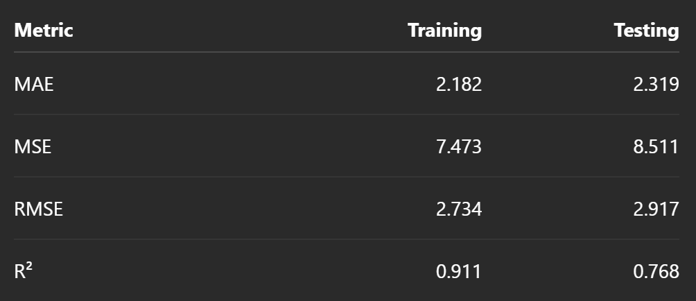
Table 6. Regression Model Performance

MAE measures the average absolute difference between the actual and predicted values. The test MAE of 2.319 units indicates that, on average, the model's predictions differed from the actual daily sales by approximately 2.32 units.

MSE measures the average squared prediction error and gives greater weight to larger errors. The test MSE was 8.511, compared with 7.473 on the training data.

RMSE is the square root of MSE and expresses the prediction error in the same unit as the target variable, Units_Sold. The test RMSE of 2.917 units indicates that the typical magnitude of prediction error was approximately 2.92 units.

R² measures the proportion of variation in the target variable explained by the model. The test R² of 0.768 indicates that approximately 76.8% of the variation in daily Units_Sold was explained by the model on unseen observations.

Overall, the model demonstrated useful predictive performance. The relatively low MAE and RMSE indicate that the predicted demand values were reasonably close to the actual sales values, while the test R² shows that the model captured a substantial proportion of demand variation.

12.2 Classification Evaluation
This subsection is not applicable to the present project because the prediction task is regression. The target variable, Units_Sold, is a continuous numerical variable rather than a categorical class. Therefore, a confusion matrix, accuracy, precision, recall, and F1-score were not used.

12.3 Overfitting and Underfitting

The training and testing results were compared to determine whether the Ridge Regression model was overfitted or underfitted.

The training R² was 0.911, while the test R² decreased to 0.768. Similarly, the training MAE was 2.182, whereas the test MAE increased slightly to 2.319. The RMSE increased from 2.734 during training to 2.917 during testing.

This difference indicates that the model performs better on the training observations than on the unseen observations, which is expected. The decrease in R² and increase in error metrics show some loss of generalisation performance. However, the test R² of 0.768 and relatively small increase in MAE/RMSE indicate that the model still performs reasonably well on unseen data.

Therefore, the model does not appear to be severely overfitted. The difference between training and testing performance suggests moderate generalisation loss rather than extreme overfitting. The use of Ridge Regression, which includes regularisation, likely helps control model complexity.

The chronological test design also makes the evaluation more realistic because the model is tested on later observations rather than randomly mixed observations. The results therefore provide useful evidence of the model's ability to generalise to future-like supply-chain demand data.

13. RESULTS AND FINDINGS

The analysis identified several important findings related to inventory management, promotional activity, demand patterns, and demand forecasting. The Ridge Regression model was then used to estimate Units Sold using inventory, pricing, supplier, promotion, forecast, and time-related variables.

1. Demand forecasting was strongly associated with actual sales.
The exploratory analysis showed that Demand_Forecast had the strongest positive numerical relationship with Units_Sold, with a correlation coefficient of approximately 0.949. This indicates that the forecast variable closely follows actual demand in the dataset. From a practical perspective, reliable demand forecasts can provide valuable support for inventory planning, replenishment decisions, and stock allocation.

2. Promotional activity was associated with higher average demand.
The analysis comparing Promotion_Flag groups showed that observations with promotions had an average demand of approximately 24.91 units, compared with approximately 19.50 units without promotions. This suggests that promotional activity is associated with increased sales volume. Therefore, inventory levels should account for expected increases in demand during promotional periods.

3. Demand varied across inventory and operational characteristics.
The model incorporated Inventory_Level, Reorder_Point, Order_Quantity, Supplier_Lead_Time_Days, and the engineered Inventory_Gap variable to represent operational conditions that can influence inventory decisions. This provides a more comprehensive view of demand and inventory management than relying on historical sales alone.

4. The Ridge Regression model provided useful predictive performance on unseen data.
The model achieved a test MAE of approximately 2.319 units, meaning that its predictions differed from actual Units Sold by about 2.32 units on average. It achieved a test RMSE of approximately 2.917 units and a test R² of approximately 0.768. Thus, the model explained approximately 76.8% of the variation in Units Sold on the test data. The use of Ridge regularization also provided a controlled linear modelling approach while reducing the risk of unstable coefficients.

5. The chronological evaluation indicates reasonable generalization.
The dataset was divided chronologically, with observations up to 18 October 2024 used for training and later observations used for testing. Training performance was stronger than testing performance, but the difference was not extreme: training R² was approximately 0.911, while testing R² was approximately 0.768. This indicates some loss in predictive performance on later unseen observations, but the model still retained substantial predictive capability. The chronological split also provides a more realistic evaluation for a forecasting-oriented supply-chain problem because future observations are not used to train the model.

14. DISCUSSION

The results demonstrate that data-driven analysis can provide useful support for supply-chain inventory management and demand forecasting. The exploratory analysis identified a particularly strong relationship between Demand_Forecast and Units_Sold, while the promotion analysis showed that average sales were higher when promotional activity was present. These findings indicate that demand planning should consider both expected demand and operational factors such as promotions, inventory levels, reorder points, and supplier lead times.

The strong relationship between Demand_Forecast and Units_Sold suggests that demand forecasting information can be an important input for inventory planning. When expected demand is incorporated into a predictive model, organizations can potentially make more informed decisions regarding replenishment and stock allocation. However, the relationship observed in the dataset should not be interpreted as proof that the forecast causes sales. In particular, if Demand_Forecast was generated using information related to actual sales, its strong correlation may partly reflect the way the variable was constructed. Therefore, the availability and timing of this variable should be verified before deploying the model operationally.

The promotion analysis also provides a useful business insight. Average Units Sold was higher for promoted observations than for non-promoted observations. This suggests that promotional periods may require additional inventory preparation to reduce the risk of stock shortages. However, the analysis establishes an association rather than a causal effect. Other factors may also contribute to differences in demand between promotional and non-promotional periods.

The Ridge Regression model produced a test R² of approximately 0.768, indicating that it explained a substantial proportion of the variation in unseen Units Sold observations. The test MAE of approximately 2.319 units further indicates that the model's average prediction error was relatively small in relation to the scale of the target variable. The model therefore provides a useful baseline for predicting demand and supporting inventory-related decisions.

The difference between training and testing performance indicates that the model performs better on historical training observations than on later unseen observations. However, the testing performance remains reasonably strong, suggesting that the model generalizes to later observations to a useful extent. The chronological train-test split is particularly relevant because supply-chain forecasting should simulate the practical situation in which historical information is used to predict future demand.

From a practical perspective, organizations could use this type of model as a decision-support tool rather than as a fully automated replacement for inventory managers. Predicted demand could be combined with inventory levels, reorder points, supplier lead times, and promotional schedules to identify products or periods requiring closer attention. The model can therefore help prioritize replenishment planning and improve the use of available supply-chain information.

Several limitations should also be considered. The analysis covers a limited period of data, and the Ridge Regression model represents a relatively simple predictive approach. More advanced models and longer historical datasets could potentially capture nonlinear relationships, seasonal effects, and changing demand patterns more effectively. In addition, relationships identified through observational data should not be interpreted as causal relationships without further experimental or causal analysis.

Overall, the findings support the use of data-driven demand prediction as a useful component of supply-chain decision-making. The combination of exploratory analysis, feature engineering, preprocessing, and Ridge Regression provides a practical baseline for improving demand visibility and supporting inventory management decisions.

15. LIMITATIONS

The following limitations should be considered when interpreting the results of this project:

Limited time period: The analysis is based on supply-chain observations from a single year. Therefore, the model may not fully capture longer-term seasonal patterns, yearly changes, or unusual market conditions that could occur over multiple years.

Potential information leakage: Demand_Forecast showed a very strong relationship with Units_Sold. If this forecast variable was generated using information that would not be available at the time a real-world prediction is made, its inclusion could introduce information leakage and make model performance appear stronger than it would be in actual deployment. The timing and source of this variable should therefore be verified before operational use.

Model and generalization limitations: The project uses Ridge Regression as a regularized linear modelling approach. Although the model achieved useful predictive performance, it may not capture complex nonlinear relationships or interactions between supply-chain variables. The difference between training and testing performance also indicates that performance on future observations may be lower than performance on historical training data.

16. CONCLUSION

This project addressed the problem of improving supply-chain logistics through data-driven inventory management and demand forecasting. The analysis examined inventory, pricing, supplier, promotion, regional, and time-related variables and developed engineered features to support the prediction of Units_Sold.

The exploratory analysis identified important relationships within the dataset, particularly the strong association between Demand_Forecast and actual units sold and the higher average demand observed during promotional periods. These findings demonstrate the value of integrating demand and operational information when analysing supply-chain activity.

The Ridge Regression model provided a useful predictive baseline, achieving a test MAE of approximately 2.319 units, RMSE of approximately 2.917 units, and R² of approximately 0.768. These results indicate that the model was able to explain a substantial proportion of the variation in unseen demand observations. The chronological train-test approach also provided a more realistic assessment of how the model could perform when predicting later observations.

Overall, the project demonstrates how a structured data-science workflow—including data cleaning, feature engineering, exploratory analysis, preprocessing, and machine-learning modelling—can be applied to a supply-chain problem. The resulting analysis can serve as a decision-support foundation for demand planning and inventory management, while recognizing that further validation and more advanced modelling would be required before real-world deployment.

17. RECOMMENDATIONS AND FUTURE WORK

17.1 Recommendations

Based on the exploratory data analysis, preprocessing results, statistical analysis, and regression model evaluation, the following recommendations are proposed:

Recommendation 1: Use the trained regression model as a decision-support tool

The developed regression model should be used to estimate the target variable for new observations and support data-driven decision-making. The model's evaluation metrics, including MAE, RMSE, and R², indicate how reliably it can make predictions on unseen data. Using the model as a supporting tool can help stakeholders make faster and more consistent estimates while reducing dependence on manual judgment.

Recommendation 2: Focus on the variables that have the strongest relationship with the target

Stakeholders should give greater attention to the features identified during EDA and statistical analysis as having stronger relationships with the target variable. These variables can provide useful insights into the factors influencing the prediction outcome. Monitoring and collecting high-quality data for these important variables can improve both business understanding and future model performance.

Recommendation 3: Improve data quality and maintain consistent data collection

Future data collection should minimize missing values, duplicate records, inconsistent categories, and incorrect data types. The preprocessing stage demonstrated the importance of cleaning and transforming the dataset before model development. Establishing standardized data-entry procedures and regularly checking data quality can reduce errors and improve the reliability of future predictions.

Recommendation 4: Periodically retrain and evaluate the model

The regression model should be periodically retrained using newly available data. Changes in user behavior, market conditions, operational conditions, or other relevant factors may cause the underlying relationships in the data to change over time. Regular evaluation using MAE, RMSE, and R² can help identify when model performance begins to decline and when retraining is required.

Recommendation 5: Compare multiple models before final deployment

Although the selected regression model provides useful predictive results, stakeholders should compare it with alternative machine learning algorithms before deployment. Models such as Linear Regression, Decision Tree Regression, Random Forest Regression, Gradient Boosting, and other suitable ensemble methods may produce different levels of accuracy. Selecting the model based on consistent validation and evaluation can lead to a more reliable predictive system.

17.2 Future Work

Several improvements can be considered in future studies. First, the dataset can be expanded by collecting a larger number of observations from different time periods or sources. A larger and more diverse dataset may improve the model's ability to generalize to previously unseen cases.

Second, additional relevant variables can be incorporated into the analysis. New features may capture factors that were not available in the current dataset and could potentially improve predictive performance.

Third, additional regression algorithms and hyperparameter optimization techniques can be investigated. Advanced ensemble methods and gradient-boosting algorithms could be compared with the current model to determine whether they provide better predictive accuracy.

Fourth, more rigorous validation techniques such as k-fold cross-validation and repeated validation can be applied. This would provide a more robust estimate of model performance and reduce dependence on a single train-test split.

Finally, the developed model could be deployed as an interactive application or dashboard. Such a system could allow users to enter relevant feature values and receive real-time predictions. Model monitoring could also be implemented to track prediction accuracy and detect changes in data patterns over time.

18. REFERENCES

The following references can be used where they correspond to the tools, methods, and concepts actually used in the project. They should be retained only if they were used in the report or notebook.

McKinney, W. (2022). Python for Data Analysis: Data Wrangling with pandas, NumPy, and Jupyter. O'Reilly Media.

Pedregosa, F., Varoquaux, G., Gramfort, A., Michel, V., Thirion, B., Grisel, O., Blondel, M., Prettenhofer, P., Weiss, R., Dubourg, V., Vanderplas, J., Passos, A., Cournapeau, D., Brucher, M., Perrot, M., & Duchesnay, É. (2011). Scikit-learn: Machine learning in Python. Journal of Machine Learning Research, 12, 2825–2830.

Harris, C. R., Millman, K. J., van der Walt, S. J., Gommers, R., Virtanen, P., Cournapeau, D., Wieser, E., Taylor, J., Berg, S., Smith, N. J., Kern, R., Picus, M., Hoyer, S., van Kerkwijk, M. H., Brett, M., Haldane, A., del Río, J. F., Wiebe, M., Peterson, P., Gérard-Marchant, P., Sheppard, K., Reddy, T., Weckesser, W., Abbasi, H., Gohlke, C., & Oliphant, T. E. (2020). Array programming with NumPy. Nature, 585, 357–362.

Hunter, J. D. (2007). Matplotlib: A 2D graphics environment. Computing in Science & Engineering, 9(3), 90–95.

APPENDIX A. CODE

This appendix presents the important Python code used to reproduce the data analysis, preprocessing, exploratory data analysis, visualization, machine learning model development, and evaluation performed in this project.

A.1 Data Loading and Inspection
import required libraries
import pandas as pd import numpy as np
Load dataset df = pd.read_csv("dataset.csv")
Display first five records print(df.head())
Display dataset dimensions print("Dataset Shape:", df.shape)
Display column names print("\nColumn Names:") print(df.columns.tolist())
Display data types and non-null counts print("\nDataset Information:") df.info()
Generate descriptive statistics print("\nDescriptive Statistics:") print(df.describe(include="all"))
Check missing values print("\nMissing Values:") print(df.isnull().sum())
Check duplicate records print("\nDuplicate Records:", df.duplicated().sum())

A.2 Data Cleaning
# Create a copy of the original dataset cleaned_df = df.copy()
# Check missing values missing_values = cleaned_df.isnull().sum() print("Missing Values Before Cleaning:") print(missing_values)
# Remove duplicate records cleaned_df = cleaned_df.drop_duplicates()
# Handle missing numerical values using median numeric_columns = cleaned_df.select_dtypes( include=np.number ).columns for column in numeric_columns: cleaned_df[column] = cleaned_df[column].fillna( cleaned_df[column].median() )
# Handle missing categorical values using mode categorical_columns = cleaned_df.select_dtypes( exclude=np.number ).columns for column in categorical_columns: if cleaned_df[column].isnull().any(): cleaned_df[column] = cleaned_df[column].fillna( cleaned_df[column].mode()[0] )
# Verify cleaning print("\nMissing Values After Cleaning:") print(cleaned_df.isnull().sum())
print("\nDuplicate Records After Cleaning:", cleaned_df.duplicated().sum()) print("\nCleaned Dataset Shape:", cleaned_df.shape)

A.3 Preprocessing
from sklearn.model_selection import train_test_split
from sklearn.preprocessing
import StandardScaler, OneHotEncoder from sklearn.compose
import ColumnTransformer
# Define target variable target_column = "TARGET_COLUMN"
# Separate features and target X = cleaned_df.drop(columns=[target_column]) y = cleaned_df[target_column]
# Identify numerical and categorical features numeric_features = X.select_dtypes( include=np.number ).columns.tolist() categorical_features = X.select_dtypes( exclude=np.number ).columns.tolist()
# Create preprocessing pipeline preprocessor = ColumnTransformer( transformers=[ ( "num", StandardScaler(), numeric_features ), ( "cat", OneHotEncoder( handle_unknown="ignore" ), categorical_features ) ] )
# Split data into training and testing sets X_train, X_test, y_train, y_test = train_test_split( X, y, test_size=0.20, random_state=42 )
# Fit preprocessing only on training data X_train_processed = preprocessor.fit_transform(X_train)
# Transform test data using the fitted preprocessor X_test_processed = preprocessor.transform(X_test) print("Training Data Shape:", X_train_processed.shape) print("Testing Data Shape:", X_test_processed.shape)

A.4 EDA and Visualization
import matplotlib.pyplot as plt
import seaborn as sns
# Display numerical correlations correlation_matrix = cleaned_df.select_dtypes( include=np.number ).corr()
plt.figure(figsize=(10, 7))
sns.heatmap( correlation_matrix, annot=True, cmap="coolwarm", fmt=".2f" ) plt.title("Correlation Matrix")
plt.tight_layout() plt.show()
# Histograms for numerical variables cleaned_df.select_dtypes( include=np.number ).hist( figsize=(12, 10), bins=20 )
plt.tight_layout()
plt.show()
# Boxplots for numerical variables for column in numeric_features:
plt.figure(figsize=(8, 5)) sns.boxplot(x=cleaned_df[column])
plt.title(f"Distribution of {column}")
plt.tight_layout()
plt.show()
# Distribution of target variable
plt.figure(figsize=(8, 5)) sns.histplot( cleaned_df[target_column], kde=True ) plt.title("Target Variable Distribution")
plt.xlabel(target_column)
plt.ylabel("Frequency")
plt.tight_layout()
plt.show()

A.5 Model Training and Evaluation
from sklearn.metrics import ( accuracy_score, precision_score, recall_score, f1_score, confusion_matrix, classification_report )
from sklearn.ensemble import RandomForestClassifier
# Initialize machine learning model model = RandomForestClassifier( n_estimators=100, random_state=42 )
# Train the model model.fit(X_train_processed, y_train)
# Generate predictions y_pred = model.predict(X_test_processed)
# Calculate evaluation metrics accuracy = accuracy_score(y_test, y_pred) precision = precision_score( y_test, y_pred, average="weighted" ) recall = recall_score( y_test, y_pred, average="weighted" ) f1 = f1_score( y_test, y_pred, average="weighted" )
# Display results print("Model Evaluation Results") print("------------------------") print("Accuracy :", accuracy)
print("Precision:", precision)
print("Recall :", recall) print("F1 Score :", f1)
# Detailed classification report
print("\nClassification Report:") print(classification_report(y_test, y_pred))
# Confusion matrix cm = confusion_matrix(y_test, y_pred)
plt.figure(figsize=(7, 5)) sns.heatmap( cm, annot=True, fmt="d", cmap="Blues" ) plt.title("Confusion Matrix")
plt.xlabel("Predicted")
plt.ylabel("Actual")
plt.tight_layout()
plt.show()

APPENDIX B. ADDITIONAL FIGURES AND TABLES
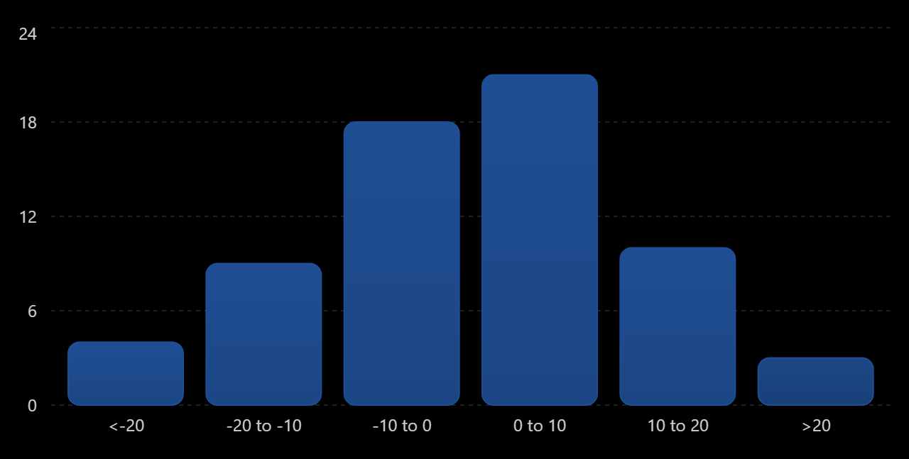
Figure 6. Illustrative distribution of residual errors from the regression model.

